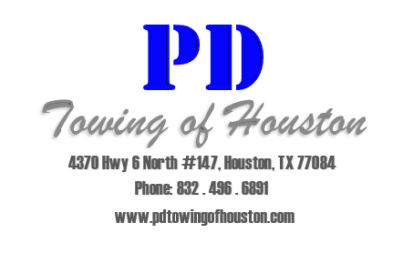
Notices and Letters

Our administrative team is able to provide you with the most comprehensive set of notices and letters to inform your residents of any changes to the parking rules as well as informing them of the need and proper use of parking permits.
All of our letters are available in English and Spanish, and can easily be translated into a number of international languages upon request.
All our notices and letters meet or exceed the regulations placed upon us by the state of Texas in terms of notifying residents of a new tow company and any changes that arise from that as well as the introduction of parking permits and their proper use.
We use bold colors and large fonts to ensure that notices and letters are not overlooked and easily visible.
Please see the following pages for examples of our notices and letters.

