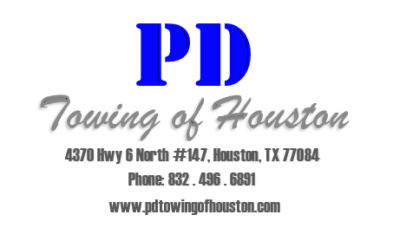

Hello,

We at PD Towing of Houston would like to have you as one of our clients. We have a multitude of services to accommodate any and all of your tow needs from lease compliance to nightly patrols for parking violations and permit enforcement.

We pride ourselves on having the newest damage free towing equipment on the road, we utilize tow trucks commonly known as “self-loaders” which allow our drivers to hook to a vehicle only touching the tires.

Some of the services we offer are:

* 24-hour dispatch service
* Sticker-ing service to keep your property free of inoperable, abandoned, and wrecked vehicles.
* We provide all signage as required by law., as well as custom signage in English and Spanish.
* All tows are digitally photographed and emailed to your office along with a tow slip showing the reason for the tow.
* We have partnered with the best storage lots who provide 24/7 vehicle release.

Other services we offer to our esteemed clients are:

* Discounted towing and lock out rates to employees and residents.
* Our own parking lot striping specialist to restripe your parking lots as needed.
* Representation for your company should a resident request to a “Tow Hearing” to contest a tow.

We look forward to discussing all we have to offer you at your convenience. If you have any questions, please feel free to contact our office.

Sincerely,

John Scott