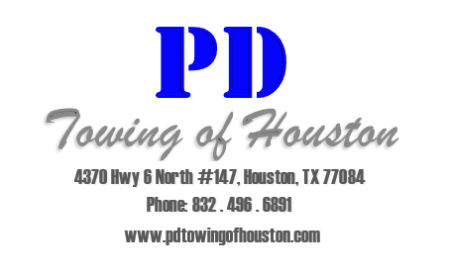
Signage
- Some of our signs are available in Spanish.
- Most of our signs are provided free of charge.
- All of our signs meet or exceed the current legal requirements.
- All of our signs are screen printed on ceroplastic, making the durable and easily visible.
- Larger signs are available in metal.
- Custom signs are also available.

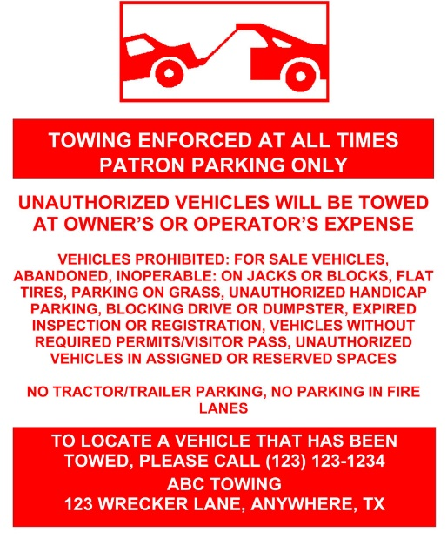
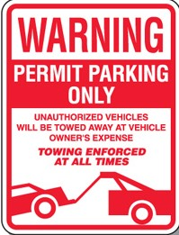
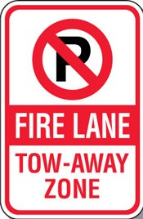
Examples of the signs we use:

