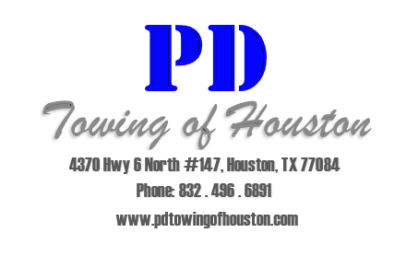
Head In Parking Addendum Notice

ATTENTION ALL RESIDENTS OF: ____________________________________

This notice is to inform and notify you and your guest that we will be enforcing HEAD IN PARKING as of _____/_____/______.
If you or your guests back a vehicle into a parking space, it WILL BE TOWED at the vehicle owners expense.
It is your responsibility to inform your guests of the HEAD IN PARKING policy. If you fail to provide them with this information or they fail to park HEAD IN, their vehicle WILL BE TOWED at the vehicle owner’s expense.
If you have any questions or concerns regarding Towing Enforcement, please contact the leasing office during regular business hours.
Thank you for your patience during these changes.

