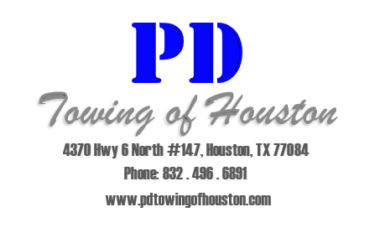
Carport Parking Lease Agreement

Date: _____________________
Carport #: __________________
Name: _______________________________ Phone #: ________________________
Apartment #: __________________________ Building #: ______________________
Make, & Model of Vehicle: _______________________________________________
Year: ________________________Color: ___________________________________
License Plate #: ____________________________ State: ______________________

The parking permit sticker MUST be placed ABOVE the registration sticker on the driver’s side of the windshield facing out. DO NOT place the sticker under tinted areas of the windshield. If the permit is NOT visible in the proper place or IS NOT CLEARLY VISIBLE IN PLAIN VIEW, the vehicle is subject to be towed.
If you sell your vehicle or move out, please remove the sticker from your vehicle and return it to the Leasing Office. If you purchase a new car, you must park in the VISITORS section until you are issued a parking permit or your vehicle is subject to be towed.
It is your responsibility to inform all guests where the visitors parking is located and to park there while on property, failure to do so may result in their vehicle being towed.
If you have any questions regarding towing enforcement or need a new permit, please contact the Leasing Office during regular business hours.
BY MY SIGNATURE BELOW I CERTIFY THAT I HAVE READ AND UNDERSTAND THE ABOVE AND HAVE RECEIVED MY PARKING PERMIT.
X_______________________________________

